**Plant Disease Detection System for Sustainable Agriculture**

A Project Report

submitted in partial fulfillment of the requirements

of

AICTE Internship on AI: Transformative Learning

with

TechSaksham – A joint CSR initiative of Microsoft & SAP

by

**Sukitha.K, sukithasaran@gmail.com**

Under the Guidance of

**P.Raja, Master Trainer, Edunet Foundation**

**ACKNOWLEDGEMENT**

We would like to take this opportunity to express our deep sense of gratitude to all individuals who helped us directly or indirectly during this thesis work.

“ I would like to extend my sincere gratitude to my project trainer, P.Raja, for their invaluable guidance and support throughout this project. Thier expertise,patience,and encouragement played a significant role in shaping my understanding of plant disease detection and system support for agriculture.

Their effort in providing constructive feedback, suggestion improvements,and facilitating my learning process has been instrumental in the successful completion of this project . I am deeply grateful for their time, energy,and dedication.

Thankyou , P.Raja, for being an exceptional mentor and for helping me grow academically and professionally.”

#### **ABSTRACT**

**Summary of the project**:

The sustainable smart system helps farmers detect vegetable leaf diseases, maximizing both the quality and quantity of vegetable products. The proposed model achieved higher accuracy and performance in vegetable plant leaf disease recognition and classification.

**Problem statement:**

Plant diseases can cause significant economic losses in agriculture, and timely and accurate detection is critical for effective disease management.

**Objectives:**

The objective is to identify the disease in leaves at an early stage and take appropriate action to stop it. In order to quickly classify diseases and carry out disease-specific diagnosis, we often use image processing techniques. Crop productivity will increase as a result of this strategy.

**Methodology:**

In order to detect plant diseases, image processing and machine learning techniques are used. Image acquisition, pre-processing, segmentation, feature extraction, and classification are steps in the process of disease detection. In the project, feature extraction using deep learning is used to identify disease.

**Key results:**

**Data Collection**: Processed plant image datasets with techniques like resizing, normalization, and augmentation for training.

**Model Training**: Leveraged pre-trained deep learning models like CNN for feature extraction and disease classification.

**Real-Time Detection**: Implemented a system for analyzing plant images and providing disease predictions along with possible remedies.

I

**Conclusion:**

The application of ML and DL techniques in plant disease detection is a rapidly evolving field with promising results. While these techniques have demonstrated their potential to accurately identify and classify plant diseases. There are still limitations and challenges that need to addressed.

II

**TABLE OF CONTENT**

**Abstract I**

**Chapter 1.**  **Introduction 1**

1.1 Problem Statement 1

1.2 Motivation 1

1.3 Objectives 2

1.4. Scope of the Project 2

**Chapter 2.**  **Literature Survey 3**

**Chapter 3.**  **Proposed Methodology**

**Chapter 4.**  **Implementation and Results**

**Chapter 5. Discussion and Conclusion**

**References**

**LIST OF FIGURES**

|  |  |  |
| --- | --- | --- |
| **Figure No.** | **Figure Caption** | **Page No.** |
|  | **objective** | **1** |
|  | **System design** | **4** |
|  | **Result snapshot-1** | **6** |
|  | **Result snapshot-2** | **7** |
|  | **Result snapshot-3** | **8** |
|  |  |  |
|  |  |  |
|  |  |  |
|  |  |  |

**LIST OF TABLES**

|  |  |  |
| --- | --- | --- |
| **Table. No.** | **Table Caption** | **Page No.** |
| **1** | **Chapter -2 Techniques** | **3** |
|  |  |  |
|  |  |  |
|  |  |  |
|  |  |  |
|  |  |  |
|  |  |  |
|  |  |  |
|  |  |  |

**CHAPTER 1**

**Introduction**

* 1. **Problem Statement:**

Plant diseases can cause significant economic losses in agriculture, and timely and accurate detection is critical for effective disease management.

* 1. **Motivation:**

It can assist farmers in the early detection of vegetable diseases, allowing them to protect their crops from damage and prevent the spread of disease across their whole yield. This, in turn, leads to an increase in both the quality and quantity of their products.

The proposed application uses the ResNet50 transfer learning model at its heart to distinguish healthy and infected leaves and classify the present disease type. The goal is to help farmers save resources and prevent economic loss by detecting plant diseases early and applying the appropriate treatment.

**“minimizing crop losses and improving overall agricultural productivity”.**

* 1. **Objective:**

The objective is to identify the disease in leaves at an early stage and take appropriate action to stop it. In order to quickly classify diseases and carry out disease-specific diagnosis, we often use image processing techniques. Crop productivity will increase as a result of this strateg.

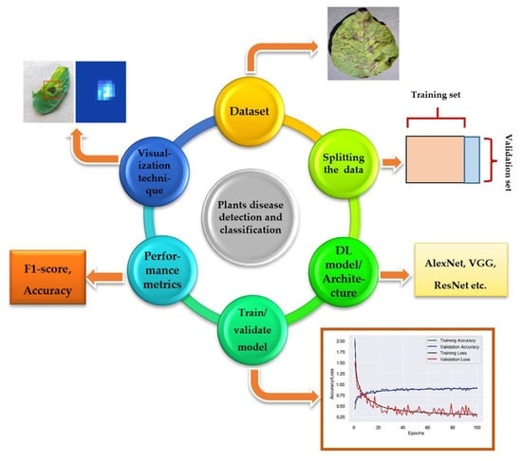

1

* 1. **Scope of the Project:**

**Scope**:

Through image analysis and algorithms, these systems enable early detection and management of plant diseases, supporting farmers and plant scientists in making informed decisions for crop protection and maximizing agricultural productivity.

**Limitation:**

**Technical Limitations:**

1. Image quality and variability: Poor image quality, varying lighting conditions, and diverse plant species can affect disease detection accuracy.

2. Limited dataset: Insufficient or biased training data can lead to poor model performance.

3. Algorithmic limitations: Current machine learning algorithms may not be able to detect complex or rare diseases.

**Practical Limitations:**

1. Scalability and cost: Implementing disease detection systems on a large scale can be costly.

2. Accessibility and infrastructure: Rural areas may lack internet connectivity, smartphones, or other necessary infrastructure.

3. User adoption and training: Farmers may need training to effectively use the disease detection system.

**2**

**CHAPTER 2**

**Literature Survey**

* 1. **Review relevant literature or previous work in this domain.**

**System Support for Agriculture:**

1. Decision Support Systems (DSS): Providing farmers with data-driven recommendations.

2. Precision Agriculture: Using technology to optimize crop yields and reduce waste.

3. Agricultural Drones: Monitoring crops and detecting disease using aerial imagery.

4. Mobile Apps: Enabling farmers to access disease.

* 1. **Mention any existing models, techniques, or methodologies related to the problem.**

**Plant Disease Detection Methods:**

1. Visual Inspection: Human observation of plant symptoms.

2. Machine Learning: Image recognition and classification using algorithms.

3. Hyperspectral Imaging: Analyzing light reflectance to detect disease.

4. Sensor-based Detection: Using sensors to monitor temperature, humidity, and other environmental factors

**Techniques:**

|  |  |  |
| --- | --- | --- |
| **Techniques** | **Limit of Detection (CFU/mL) [12]** | **Advantages** |
| PCR | 103–104 | Mature and common technology, portable, easy to operate. |
| FISH | 103 | High sensitivity. |
| ELISA | 105–106 | Low cost, visual color change can be used for detection. |
| IF | 103 | High sensitivity, target distribution can be visualized. |

**4**

**2.3 Higlight the gaps or limitations in existing solutions and how your project will address them:**

**Gaps in Plant Disease Detection:**

1. Limited Accuracy: Existing solutions may not accurately detect diseases, especially in early stages.

2. Lack of Standardization: Different solutions use varying methods, making it challenging to compare results.

3. Insufficient Data: Limited datasets and lack of diversity in plant species and diseases hinder model training.

4. Difficulty in Detecting Complex Diseases: Existing solutions struggle to detect diseases with complex symptoms or those that resemble other conditions.

**Limitations in System Support for Agriculture:**

1. Limited Accessibility: Many solutions are not accessible to small-scale farmers or those in remote areas.

2. High Cost: Some solutions are expensive, making them unaffordable for many farmers.

3. Lack of Integration: Existing solutions often operate in isolation, failing to integrate with other agricultural systems.

4. Insufficient User Support: Farmers may not receive adequate training or support to effectively use disease detection systems.

**Future Directions:**

1. Developing More Accurate Detection Models: Improving model accuracy through advanced machine learning techniques and larger datasets.

2. Increasing Accessibility and Affordability: Developing cost-effective and user-friendly solutions for small-scale farmers.

3. Enhancing Integration and Interoperability: Designing solutions that seamlessly integrate with other agricultural systems.

4. Providing Comprehensive User Support: Offering training, support, and resources to help farmers effectively use disease detection systems.

5

**CHAPTER 3**

**Proposed Methodology**

* 1. **System Design:**

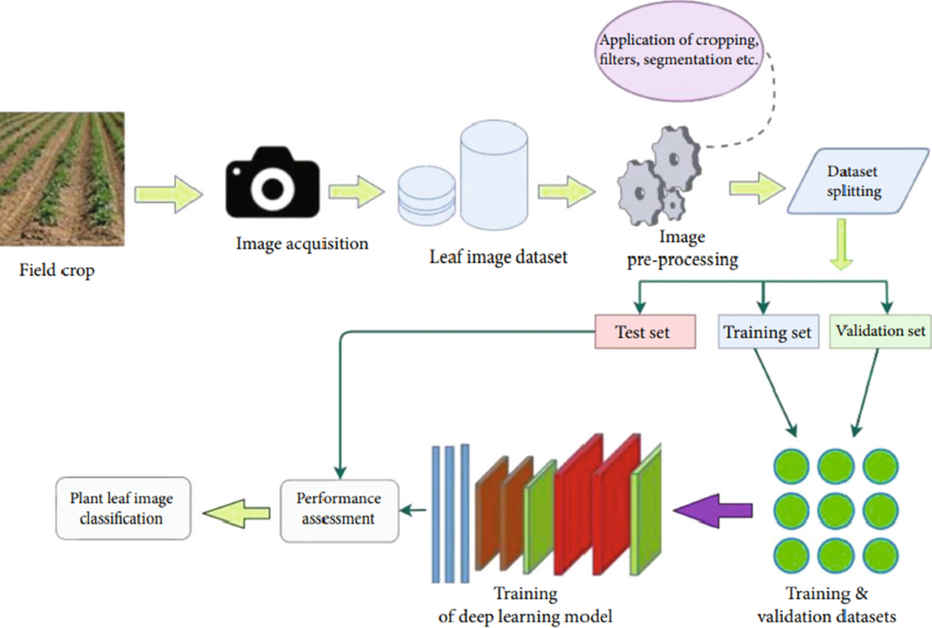

The detection and classification of crop diseases is an essential use of DL, ML, and computer vision techniques in agriculture industries [[1](https://journalofbigdata.springeropen.com/articles/10.1186/s40537-023-00863-9#ref-CR1)]. The aim is to develop algorithms and techniques based on images of leaves or other plant features that can automatically detect and classify agricultural plant diseases. This can help farmers assist and manage the disease. Following a detailed and critical study of numerous recent ML and DL-based approaches developed for plant disease detection and classification in the literature, the author has summarised a few key challenges in crop disease detection and classification, allowing the research community to investigate the causes that may have a significant impact on real-time-based systems for plant identification and diagnosis. Some factors and issues may have an impact on disease identification and classification

6

* 1. **Requirement Specification:**
     1. **Hardware Requirements:**
* Pc with core 17 processor
* 8GB RAM or above
* 300GB hard disk or above
* 2GB graphic card or above
  + 1. **Software Requirements:**
* Windows 10
* Python 3.7
* Anaconda (jupeter)
* Python packages

**7**

**CHAPTER 4**

**Implementation and Result**

* 1. **Snap Shots of Result:**

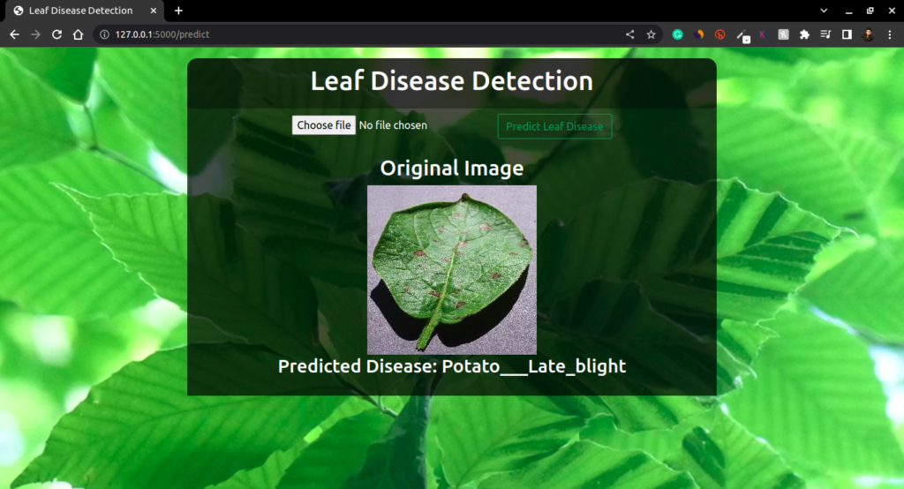

8

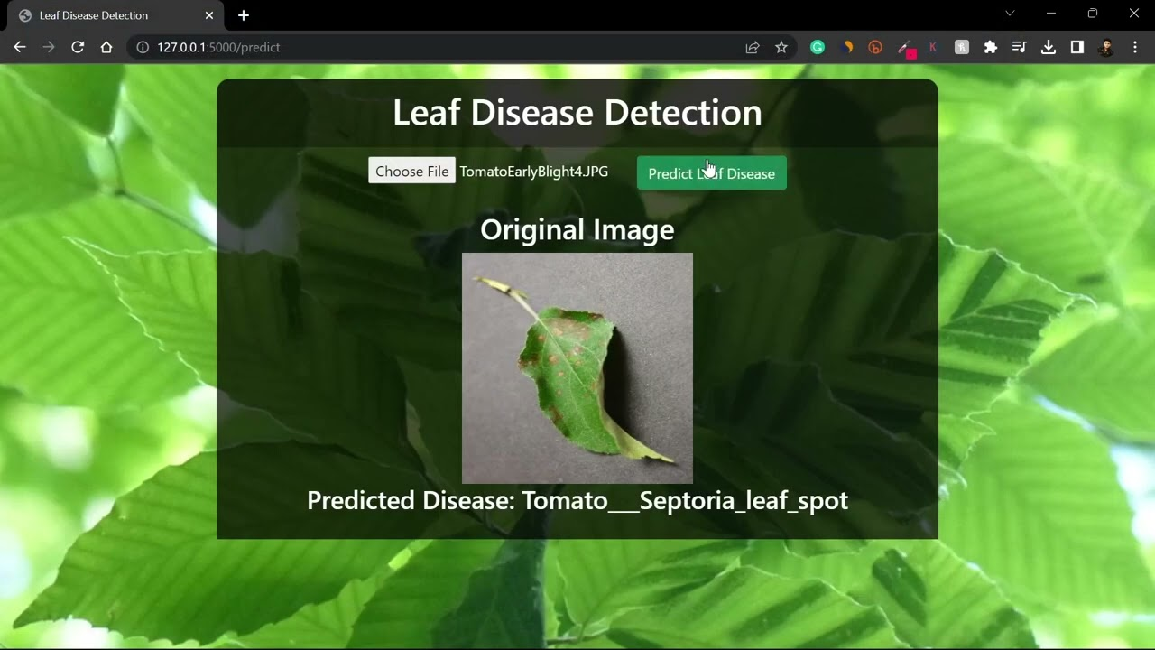

9

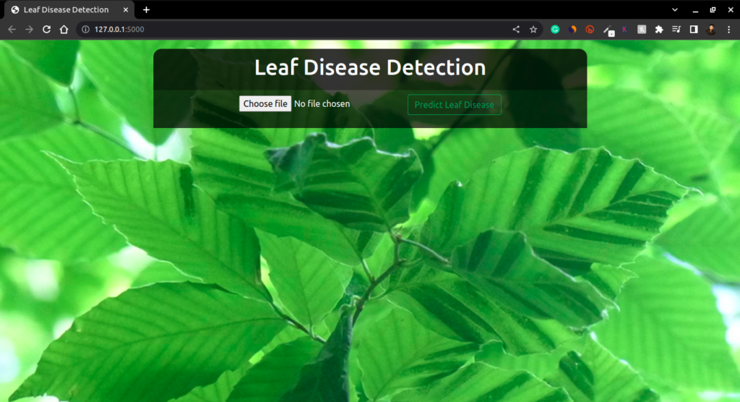

* 1. **GitHub Link for Code:**

**https://github.com/sukithasaran/sukitha2.git**

**10**

**CHAPTER 5**

**Discussion and Conclusion**

* 1. **Future Work:**

In the future, we plan to explore the use of more advanced machine learning models, suchas deep neural networks, to further improve the accuracy of the plant leaf disease detection system.

➢ Another area of future work could be to expand the dataset used to train the model, in order to increase its ability to detect a wider range of plant diseases and to better handle variations in environmental conditions.

➢ We also plan to investigate the use of transfer learning, which would enable us to leverage pre-trained models to speed up the training process and improve overall accuracy.

➢ In addition, we could explore the integration of additional sensors or data sources to further improve the system's ability to detect and diagnose plant diseases.

➢ Finally, we could consider implementing a real-time monitoring and alert system, which would enable farmers to quickly identify and respond to potential plant diseases before they spread and cause significant damage to their crops.

**11**

* 1. **Conclusion:**

**➢ Improved crop yields:**

By detecting and identifying plant diseases at an early stage, farmers can take measures to prevent the spread of the disease and save their crops. This can help improve crop yields and increase food production, which is particularly important in areas with food scarcity.

**➢ Reduced use of pesticides:**

Pesticides can be harmful to both the environment and human health. By using plant leaf disease detection, farmers can reduce their reliance on pesticides by identifying and treating specific areas affected by plant diseases, rather thanspraying entire fields.

**➢ Cost-effective:**

Plant leaf disease detection is a cost-effective way of identifying plant diseases compared to traditional methods that rely on visual inspection. This can save farmers time and money, particularly in areas where resources are limited.

**➢ Technology adoption:**

By using advanced technology in agriculture, farmers can Plant Leaf Disease Detection Using Deep Learning Dept. of CSE, SSGMCE, Shegaon Session 2022-23 68 improve their efficiency, productivity and income. The adoption of technology such as plant leaf disease detection can help bridge the technology gap in agriculture and improve the livelihoods of smallholder farmers.

**➢ Training and awareness:**

The implementation of plant leaf disease detection requires training and awareness-building among farmers and extension workers. This can help build capacity in agriculture and improve the knowledge and skills of farmers, which can lead to better decision-making and management of their crops.

**12**

➢ Overall, the plant leaf disease detection project has the potential to make a positive social impact by improving crop yields, reducing the use of harmful pesticides, and increasing the adoption of technology in agriculture.

**13**

**REFERENCES**

[1] Gaurav Verma, CharuTaluja, Abhishek Kumar Saxena “Vision Based Detection and Classification of Disease on Rice Crops Using Convolutional Neural Network” ,2019

[2] Nikhil Shah1, Sarika Jain2 “Detection of Disease in Cotton Leaf using Artificial Neural Network”,2019

[3] Ch. Usha Kumari “Leaf Disease Detection: Feature Extraction with K-means clustering and Classification with ANN”,2019

[4] S. D.M., Akhilesh, S. A. Kumar, R. M.G. and P. C., "Image based Plant Disease Detection in Pomegranate Plant for Bacterial Blight," 2019 International Conference on Communication and Signal Processing (ICCSP), 2019, pp. 0645-0649, doi: 10.1109/ICCSP.2019.8698007.

[5] H. Al-Hiary, S. Bani-Ahmad, M. Reya

[6] lat, M. Braik and Z. ALRahamneh “Fast and Accurate Detection and Classification of Plant Diseases”, 2011

[7] Kumar, M., Gupta, P., Madhav, P., & Sachin, “Disease Detection in Coffee Plants UsingConvolutional Neural Network”,2020

[8] R. M. Haralick, K. Shanmugam and I. Dinstein, "Textural Features for Image Classification," in IEEE Transactions on Systems, Man, and Cybernetics, vol. SMC3, no. 6, pp. 610-621, Nov. 1973, doi: 10.1109/TSMC.1973.4309314.

[9] Francis, J., AntoSahayaDhas D, & Anoop B K.,” Identification of leaf diseases in pepper plants using soft computing techniques.”,2016

14